LAPORAN PRAKTIKUM SISTEM OPERASI



Oleh:

Jesika Anjarwati

L200210258

Kelas E

**UNIVERSITAS MUHAMMADIYAH SURAKARTA TAHUN AJARAN 2021/2022**

**Lembar Kerja Praktikum**

**Pengenalan Sistem Pengembangan OS dengan PC Simulator ‘Bochs’**

Langkah - langkah:

1. 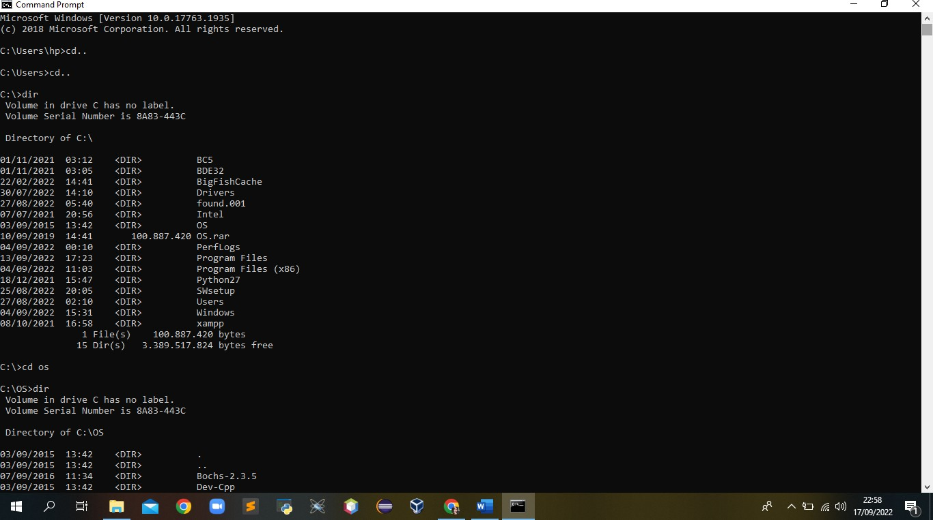Menuju ke direktori kerja

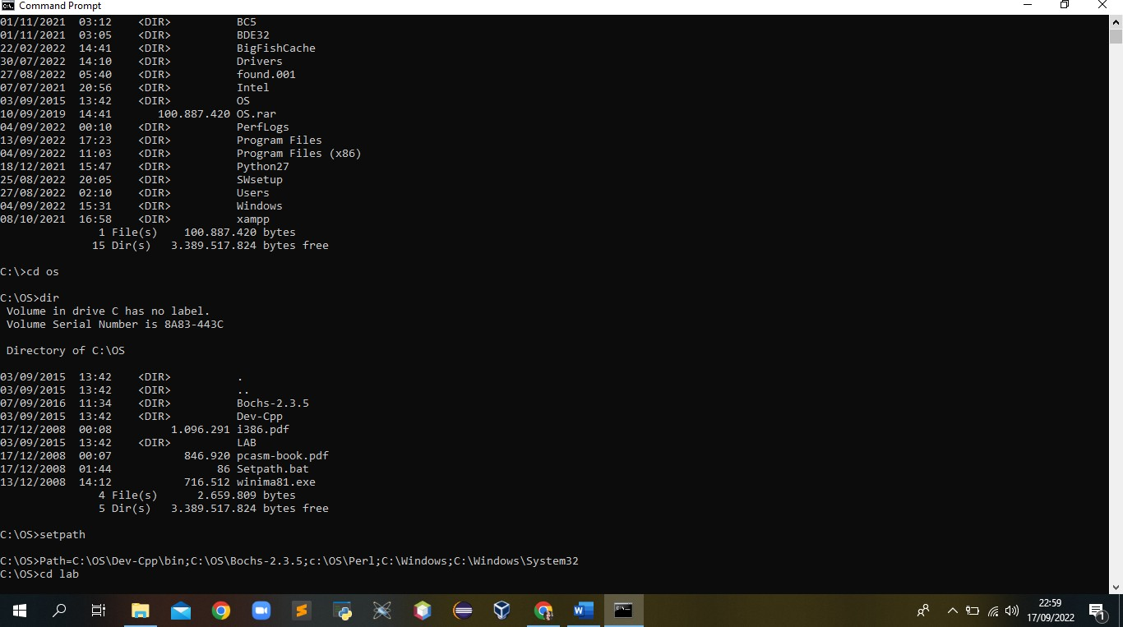

1. 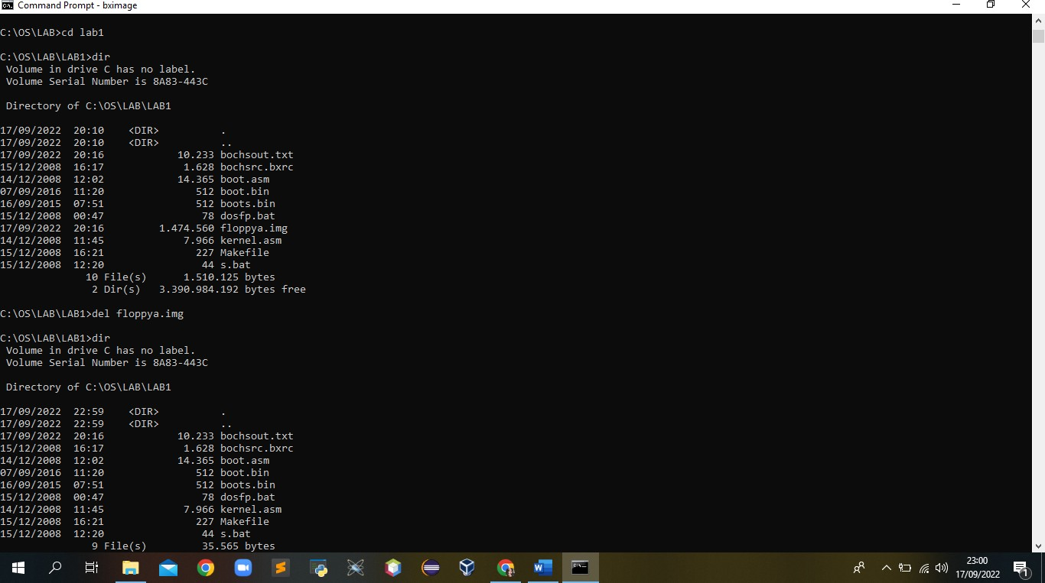Melihat isi direktori kerja

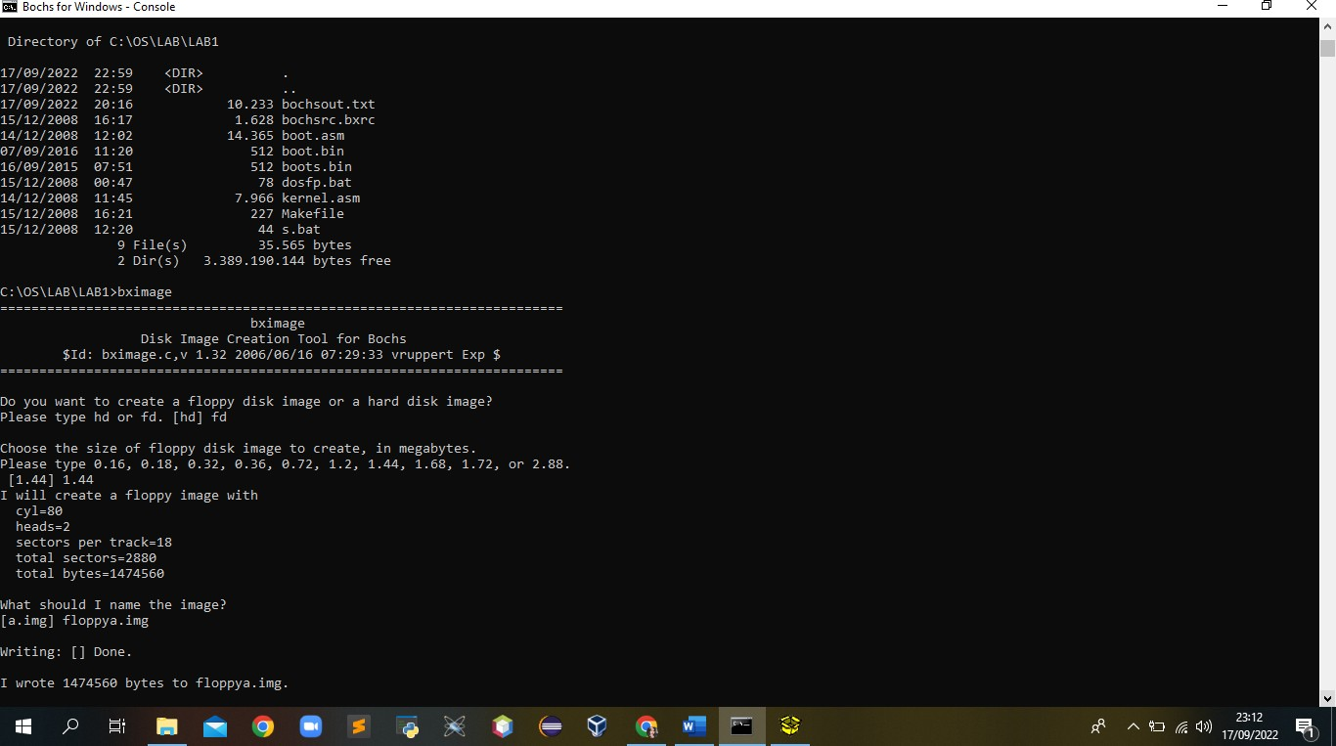

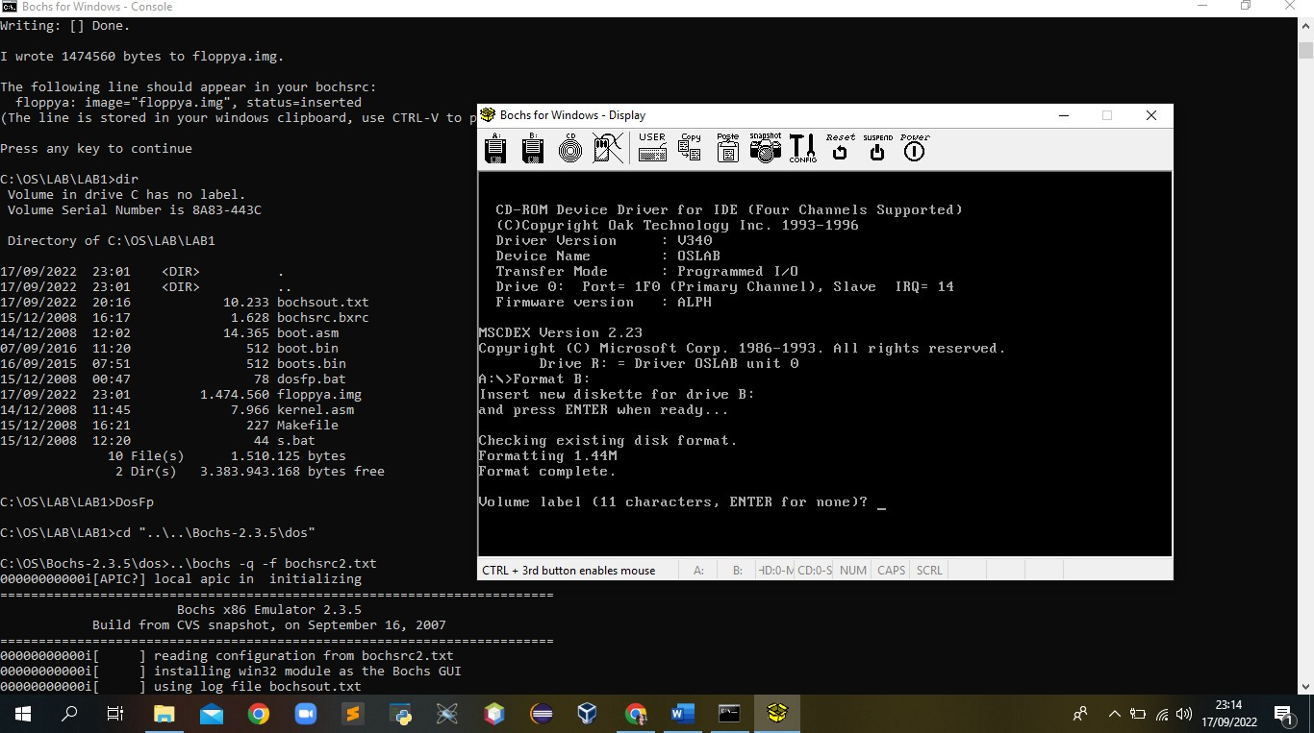

1. 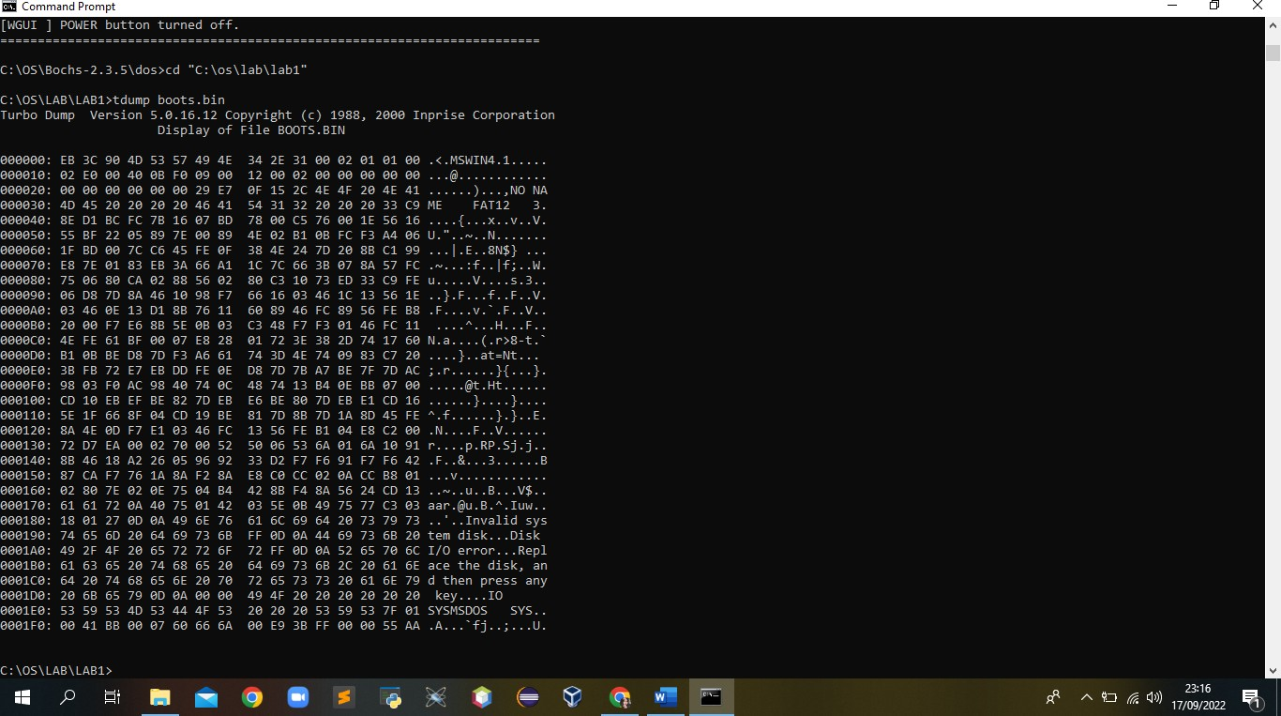Melihat data dalam boot sector
2. 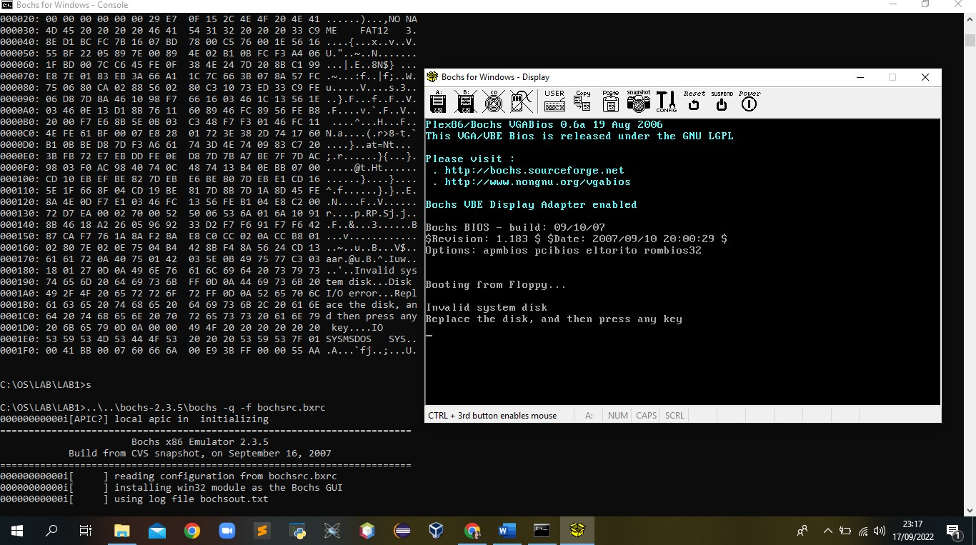‘Boot’ PC-Simulator dengan file image ‘floppya.img’

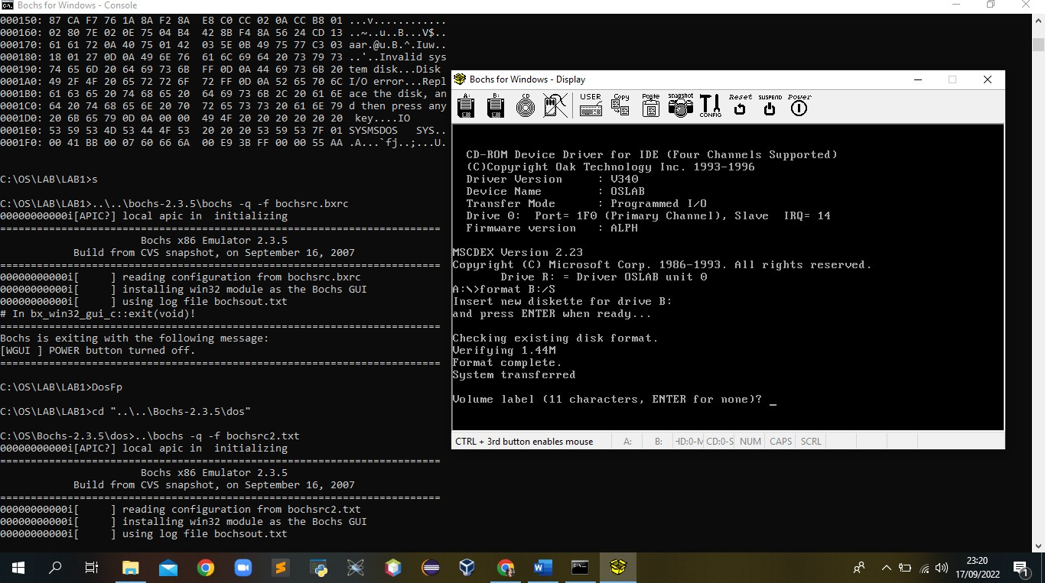

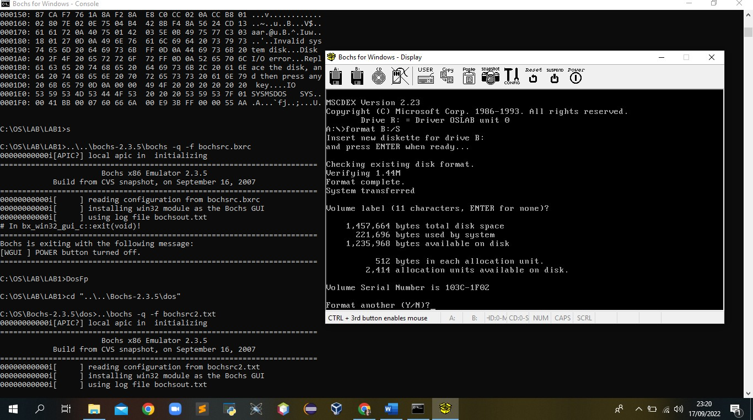

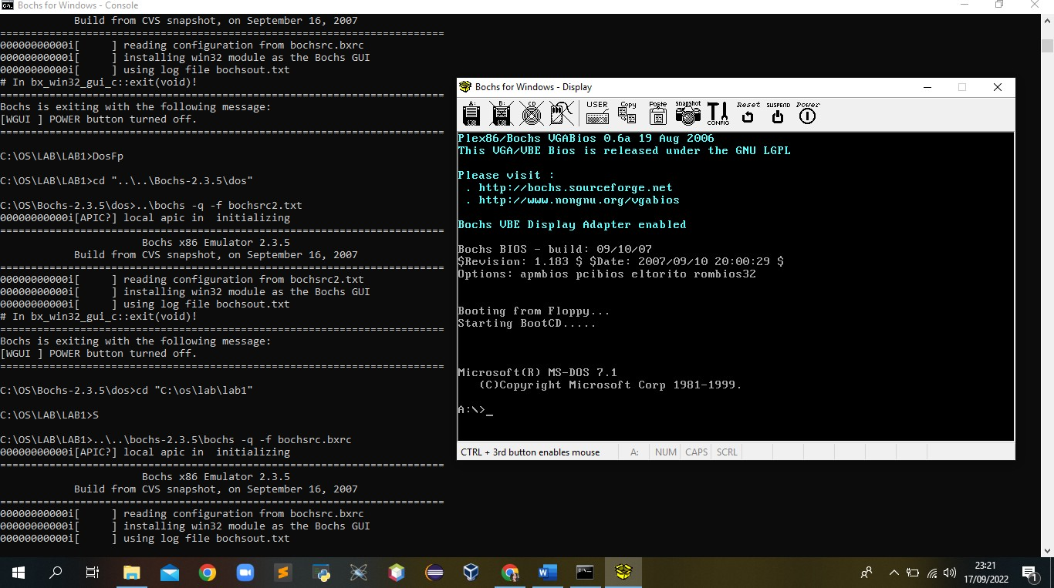

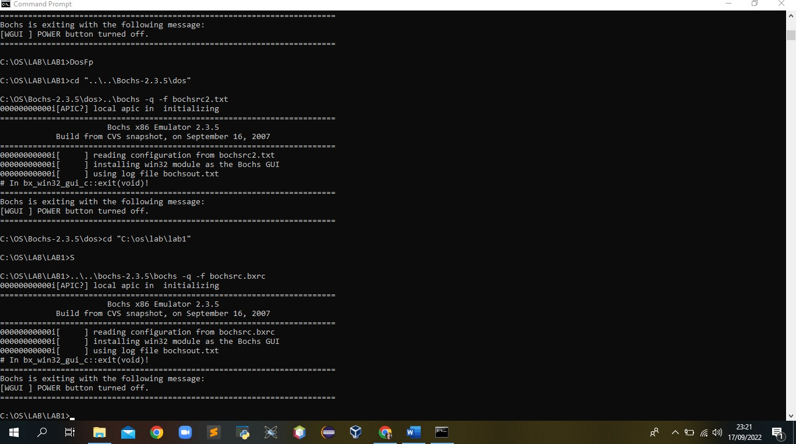

Tugas:

1. Kode ‘ASCII’ adalah singkatan dari American Standard Code for Information Interchange atau Kode Standar Amerika untuk pertukaran informasi, adalah standar pengkodean karakter untuk alat komunikasi. Kode ASCII mewakili teks dalam komputer, peralatan telekomunikasi, dan perangkat lainnya.

Contohnya, karakter “a” memiliki kode ASCII 97, dan karakter “A” memiliki kode ASCII 65.

Tabel kode ASCII:

|  |  |  |  |  |  |  |  |  |  |  |  |  |  |  |  |  |
| --- | --- | --- | --- | --- | --- | --- | --- | --- | --- | --- | --- | --- | --- | --- | --- | --- |
| **Binary** | **Oct** | **Dec** | **Hex** | **Chr** |  | **Binary** | **Oct** | **Dec** | **Hex** | **Chr** |  | **Binary** | **Oct** | **Dec** | **Hex** | **Chr** |
| 010 0000 | 040 | 32 | 20 | sp | 100 0000 | 100 | 64 | 40 | @ | 110 0000 | 140 | 96 | 60 | ` |
| 010 0001 | 041 | 33 | 21 | ! | 100 0001 | 101 | 65 | 41 | A | 110 0001 | 141 | 97 | 61 | a |
| 010 0010 | 042 | 34 | 22 | “ | 100 0010 | 102 | 66 | 42 | B | 110 0010 | 142 | 98 | 62 | b |
| 010 0011 | 043 | 35 | 23 | # | 100 0011 | 103 | 67 | 43 | C | 110 0011 | 143 | 99 | 63 | c |
| 010 0100 | 044 | 36 | 24 | $ | 100 0100 | 104 | 68 | 44 | D | 110 0100 | 144 | 100 | 64 | d |
| 010 0101 | 045 | 37 | 25 | % | 100 0101 | 105 | 69 | 45 | E | 110 0101 | 145 | 101 | 65 | e |
| 010 0110 | 046 | 38 | 26 | & | 100 0110 | 106 | 70 | 46 | F | 110 0110 | 146 | 102 | 66 | f |
| 010 0111 | 047 | 39 | 27 | ‘ | 100 0111 | 107 | 71 | 47 | G | 110 0111 | 147 | 103 | 67 | g |
| 010 1000 | 050 | 40 | 28 | ( | 100 1000 | 110 | 72 | 48 | H | 110 1000 | 150 | 104 | 68 | h |
| 010 1001 | 051 | 41 | 29 | ) | 100 1001 | 111 | 73 | 49 | I | 110 1001 | 151 | 105 | 69 | i |
| 010 1010 | 052 | 42 | 2A | * | 100 1010 | 112 | 74 | 4A | J | 110 1010 | 152 | 106 | 6A | j |
| 010 1011 | 053 | 43 | 2B | + | 100 1011 | 113 | 75 | 4B | K | 110 1011 | 153 | 107 | 6B | k |
| 010 1100 | 054 | 44 | 2C | , | 100 1100 | 114 | 76 | 4C | L | 110 1100 | 154 | 108 | 6C | l |
| 010 1101 | 055 | 45 | 2D | - | 100 1101 | 115 | 77 | 4D | M | 110 1101 | 155 | 109 | 6D | m |
| 010 1110 | 056 | 46 | 2E | . | 100 1110 | 116 | 78 | 4E | N | 110 1110 | 156 | 110 | 6E | n |
| 010 1111 | 057 | 47 | 2F | / | 100 1111 | 117 | 79 | 4F | O | 110 1111 | 157 | 111 | 6F | o |
| 011 0000 | 060 | 48 | 30 | 0 | 101 0000 | 120 | 80 | 50 | P | 111 0000 | 160 | 112 | 70 | p |
| 011 0001 | 061 | 49 | 31 | 1 | 101 0001 | 121 | 81 | 51 | Q | 111 0001 | 161 | 113 | 71 | q |
| 011 0010 | 062 | 50 | 32 | 2 | 101 0010 | 122 | 82 | 52 | R | 111 0010 | 162 | 114 | 72 | r |
| 011 0011 | 063 | 51 | 33 | 3 | 101 0011 | 123 | 83 | 53 | S | 111 0011 | 163 | 115 | 73 | s |
| 011 0100 | 064 | 52 | 34 | 4 | 101 0100 | 124 | 84 | 54 | T | 111 0100 | 164 | 116 | 74 | t |
| 011 0101 | 065 | 53 | 35 | 5 | 101 0101 | 125 | 85 | 55 | U | 111 0101 | 165 | 117 | 75 | u |
| 011 0110 | 066 | 54 | 36 | 6 | 101 0110 | 126 | 86 | 56 | V | 111 0110 | 166 | 118 | 76 | v |
| 011 0111 | 067 | 55 | 37 | 7 | 101 0111 | 127 | 87 | 57 | W | 111 0111 | 167 | 119 | 77 | w |
| 011 1000 | 070 | 56 | 38 | 8 | 101 1000 | 130 | 88 | 58 | X | 111 1000 | 170 | 120 | 78 | x |
| 011 1001 | 071 | 57 | 39 | 9 | 101 1001 | 131 | 89 | 59 | Y | 111 1001 | 171 | 121 | 79 | y |
| 011 1010 | 072 | 58 | 3A | : | 101 1010 | 132 | 90 | 5A | Z | 111 1010 | 172 | 122 | 7A | z |
| 011 1011 | 073 | 59 | 3B | ; | 101 1011 | 133 | 91 | 5B | [ | 111 1011 | 173 | 123 | 7B | { |
| 011 1100 | 074 | 60 | 3C | < | 101 1100 | 134 | 92 | 5C | \ | 111 1100 | 174 | 124 | 7C | | |
| 011 1101 | 075 | 61 | 3D | = | 101 1101 | 135 | 93 | 5D | ] | 111 1101 | 175 | 125 | 7D | } |
| 011 1110 | 076 | 62 | 3E | > | 101 1110 | 136 | 94 | 5E | ^ | 111 1110 | 176 | 126 | 7E | ~ |
| 011 1111 | 077 | 63 | 3F | ? | 101 1111 | 137 | 95 | 5F | _ |  | | | | |

1. Daftar perintah Bahasa Assembly untuk mesin intel keluarga x86

|  |  |  |  |  |  |
| --- | --- | --- | --- | --- | --- |
| **Perintah** | **Arti** | **Syarat** | **Kasus** | **Keterangan** | **Ikut CMP?** |
| **JA** | jump if above | CF = 0 𝖠  ZF = 0 | Unsingned | Lompat bila op 1 > op 2 | ya |
| **JNBE** | jump if not  below or equal |
| **JB** | jump if below | CF = 1 𝖠  ZF = 0 | Unsingned | Lompat bila op 1 < op 2 | ya |
| **JNAE** | jump if not above  or equal |
| **JAE** | jump if above or  equal | CF = 0 V  ZF = 1 | Unsingned | Lompat bila op 1 ≥ op 2 | ya |
| **JNB** | jump if not below |
| **JBE** | jump is below or  equal | CF = 1 V ZF = 1 | Unsingned | Lompat bila op 1 ≤ op 2 | ya |
| **JNA** | jump is not above |
| **JG** | jump if greater | OF = 0 𝖠  ZF = 0 | Signed | Lompat bila op 1 > op 2 | ya |
| **JNLE** | jump if not less  or equal |
| **JGE** | jump if greater or  equal | OF = 0 V ZF = 1 | Signed | Lompat bila op 1 ≥ op 2 | ya |
| **JNL** | jump if not less  than |
| **JL** | jump if less than | OF = 1 𝖠  ZF = 0 | Signed | Lompat bila op 1 < op 2 | ya |
| **JNGE** | jump if not  greater or equal |

Keterangan:

“op” = operand